East Peak Countryside Associates CIC
Safeguarding Children Code of Behaviour

You must:

- treat all children and young people with respect
- provide an example of good conduct you wish others to follow
- ensure that, whenever possible, there is more than one adult present during activities with children and young people or at least that you are within sight or hearing of others
- respect a young person's right to personal privacy/encourage young people and adults to feel comfortable and caring enough to point out attitudes or behaviour they do not like
- remember that someone else might misinterpret your actions, no matter how well-intentioned
- be aware that even physical contact with a child or young person may be misinterpreted
- recognise that special caution is required when you are discussing sensitive issues with children or young people
- operate within (insert name of organisation) principles, guidance and Safeguarding Children policy
- challenge unacceptable behaviour and report all allegations/suspicions of abuse.

You must not:

- have inappropriate physical or verbal contact with children or young people
- allow yourself to be drawn into inappropriate attention-seeking behaviour
- make suggestive or derogatory remarks or gestures in front of children or young people
- jump to conclusions about others without checking facts
- either exaggerate or trivialise child abuse issues
- show favouritism to any individual
- rely on your good name or that of East Peak Countryside Associates CIC to protect you
- believe "it could never happen to me"
- take a chance when common sense, policy or practice suggests another more prudent approach.

You should give guidance and support to inexperienced helpers.

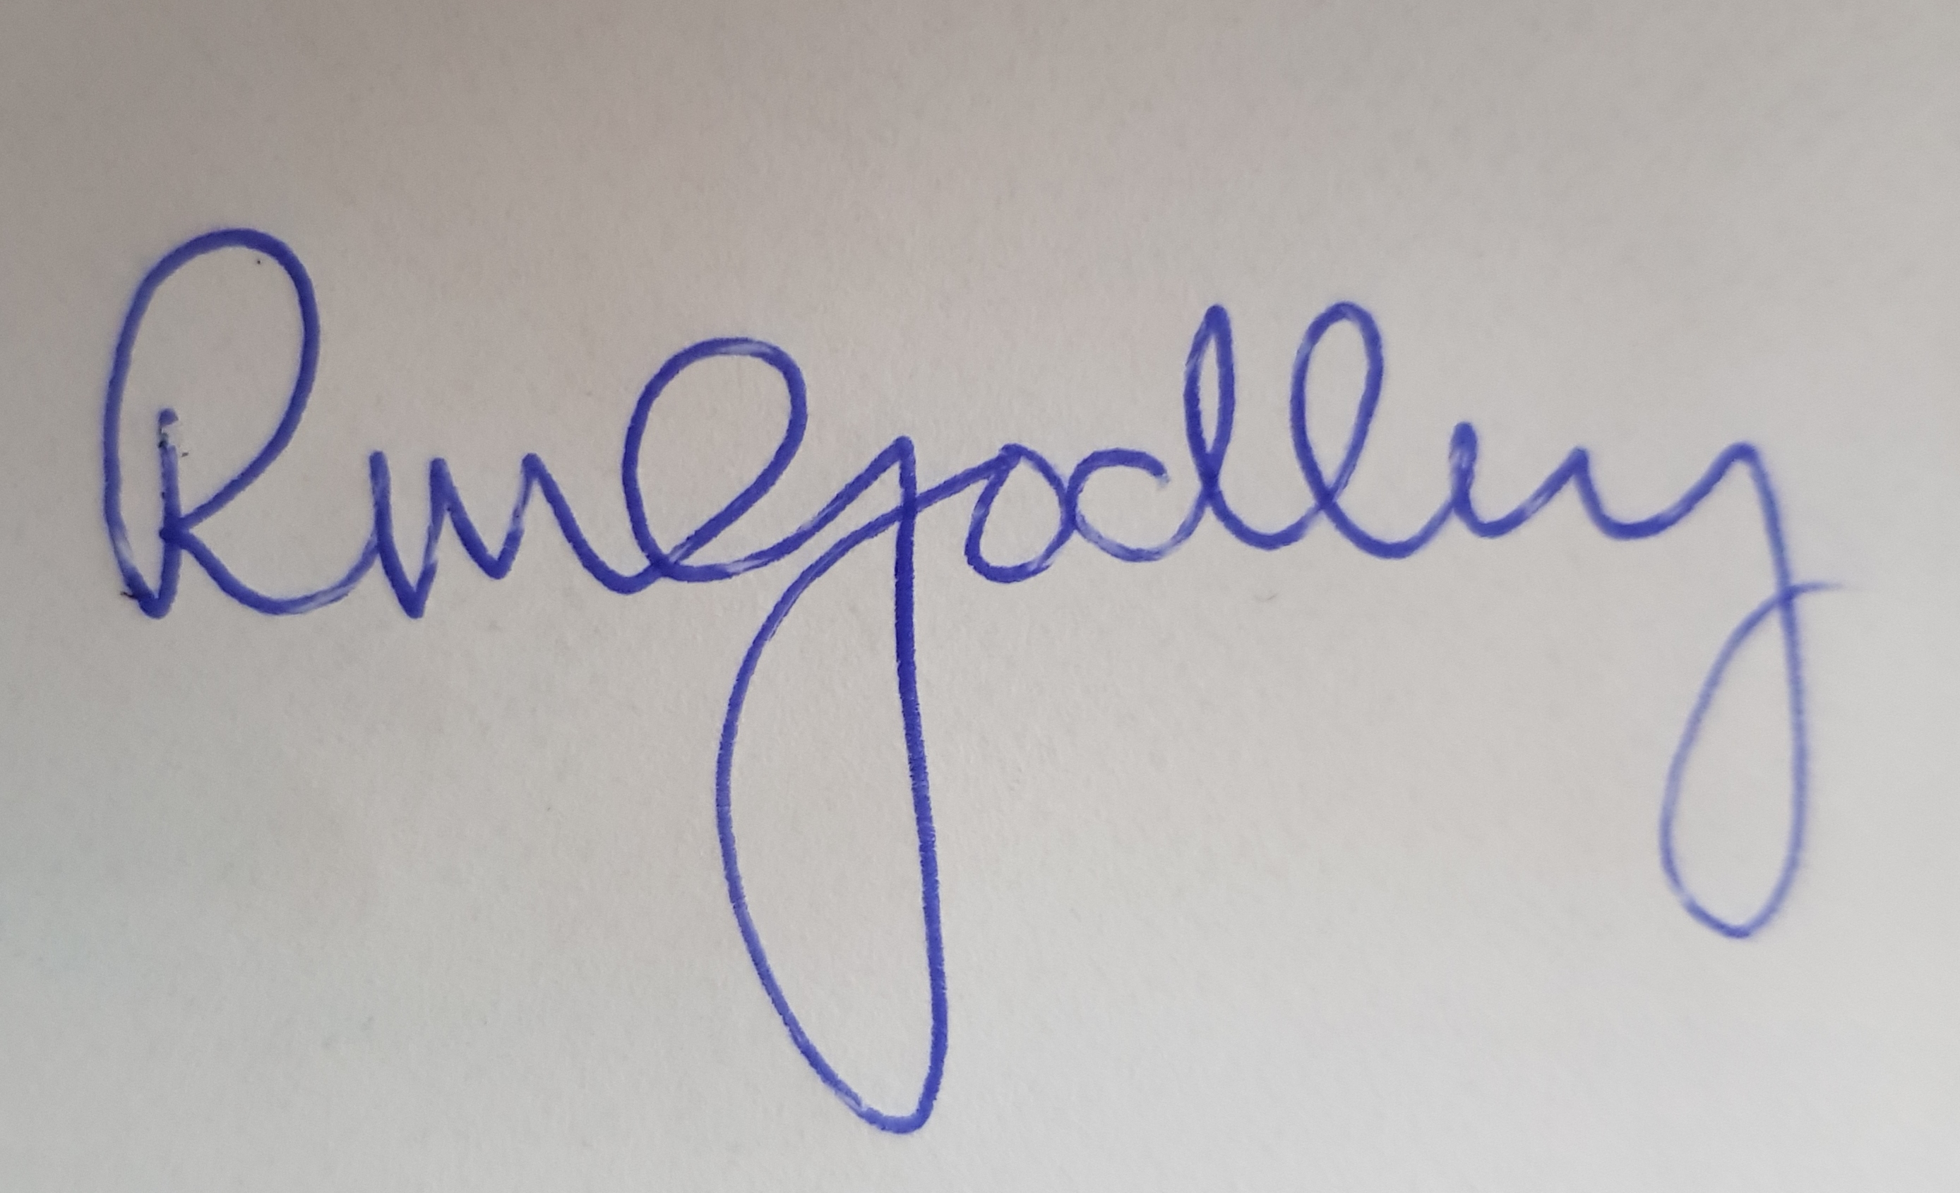
Director’s Signature: _________________________________

Adopted on: 17th July 2012

Reviewed on : 17th July 2020

